OFFICIAL REPORT by the CIE

on

AUSTRALIAN – DUTCH HERITAGE DAY

14 June 2012, The Hague

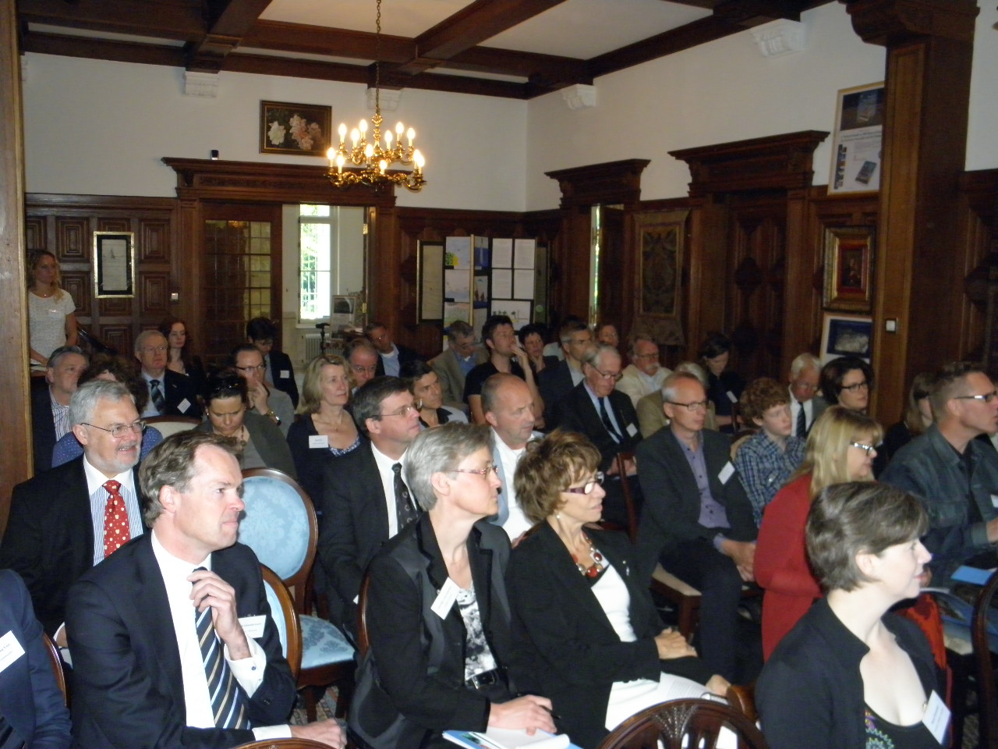
Photo 1: The Australian-Dutch Heritage Day The Hague (source: CIE).

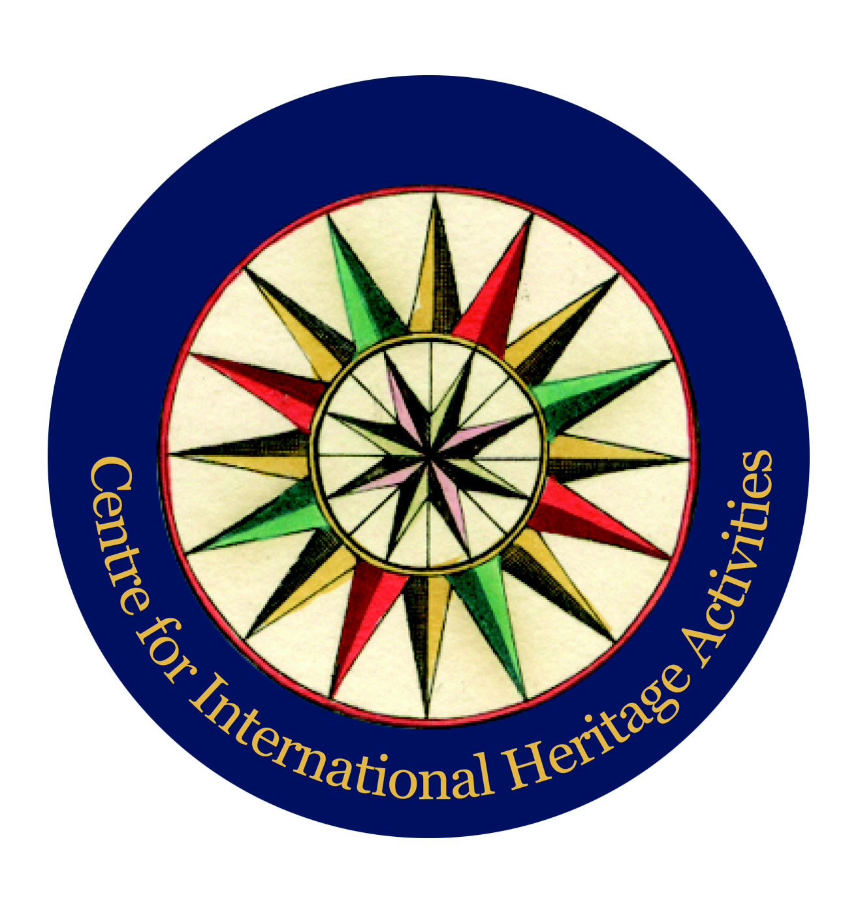
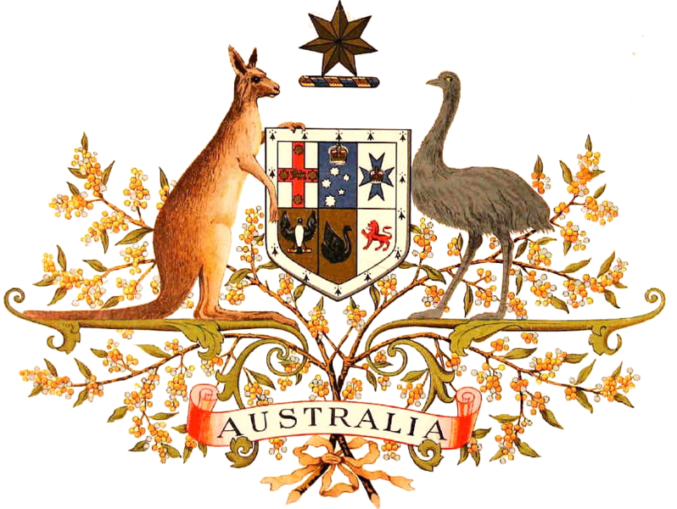

Table of content

I. Introduction…………………………………………………………………………………………...3

II. Overview of the day……………………………………………….…………………………...……..3

III. Mutual Heritage in practice……………………………………….…………………………...……..3

IV. Detailed report panel discussion intercultural cooperation…………………………….……….……..6

V. Detailed report panel discussion mercantile heritage…..……..……………..….…….…….…..….…...8

VI. Detailed report presentation ‘Towards 2016’………………………………….….…….……...….…11

VII. Conclusions and recommendations Australian-Dutch Heritage Day The Hague.……….....….….....12

- Introduction

The CIE – Centre for International Heritage Activities has as one of its aims to make international cooperation in the field of heritage open to the public, specialists and governments. In addition, the CIE strives for further collaboration between parties in the heritage field and greater professionalism. One of the tools that the CIE uses is the organization of Heritage Days. On 14 June 2012 the Australian-Dutch Heritage Day was organized in collaboration with the Embassy of Australia in The Hague and Museum Volkenkunde in Leiden, as part of the Australian Dutch Heritage Cooperation Project.
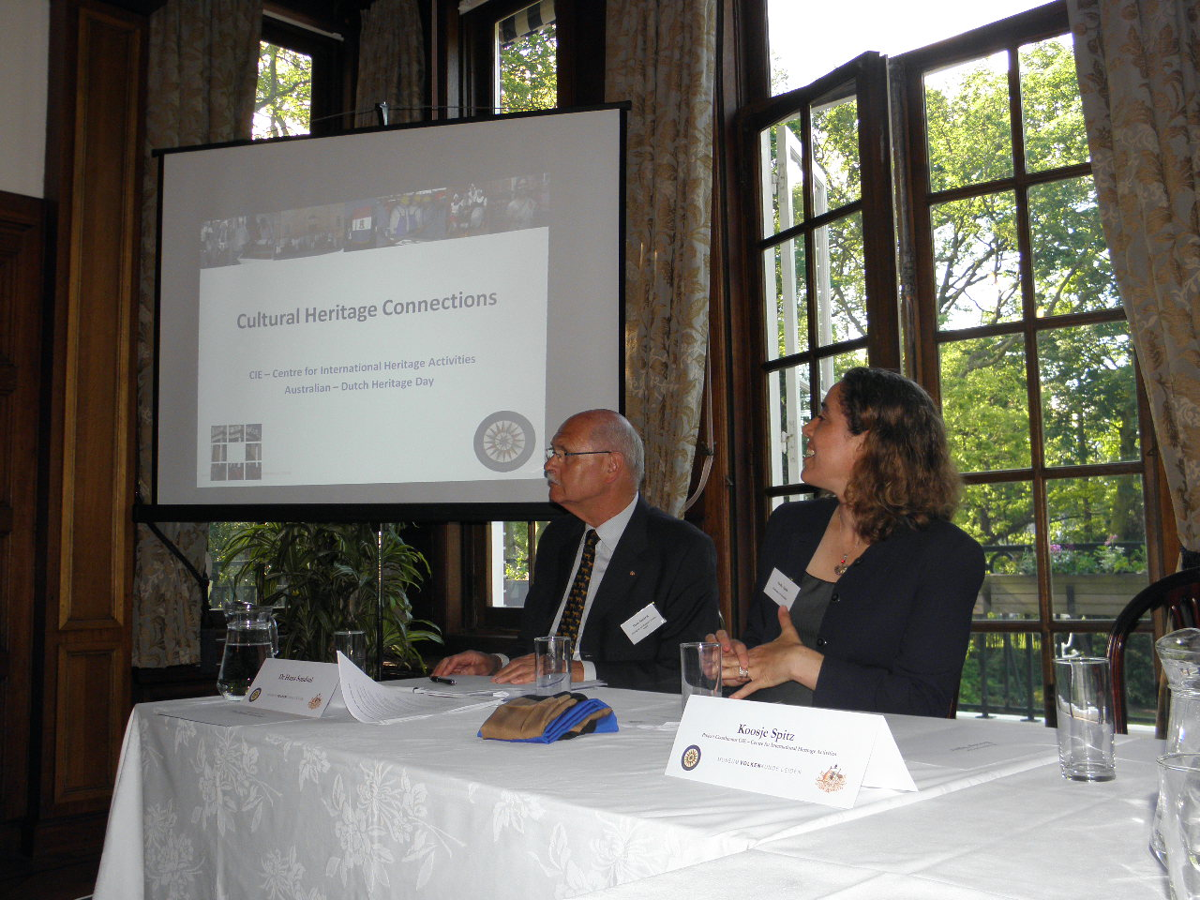
The Heritage Day was held in the residence of the Ambassador of Australia to the Netherlands, H.E. Neil Mules AO. On 14 June, professionals and specialists working in the field of Australian-Dutch heritage gathered in the residence to exchange experiences and knowledge on projects and activities. In addition, experts were given the possibility to present their project(s) through the submission of a poster. These were displayed in the residence.

The Heritage Day in The Hague consisted of a plenary programme that was divided into three parts: ‘Introduction into the Australian-Dutch Heritage Field’, ‘Mutual Cultural Heritage in Practice’ and ‘Towards 2016’, where projects and ideas for the lead up to the Dirk Hartog commemoration year 2016 were presented. The full programme consisted of two lectures by keynote speakers, various presentations and panel discussions.
Photo 2: Dr Hans Sondaal and Sally Aplin (source: CIE).

- Introduction into the Australian-Dutch Heritage Field

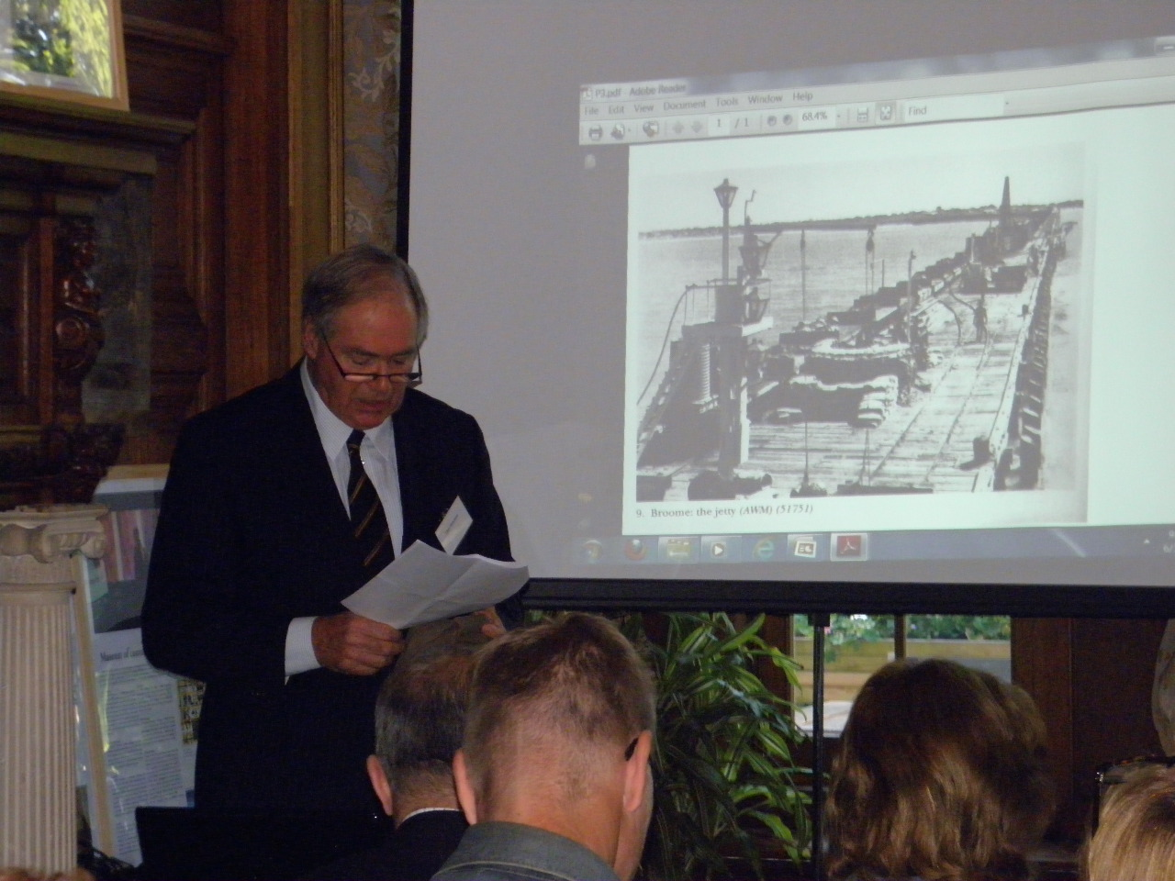
Dr Hans Sondaal, Chairman of the day, opened the event followed by words of welcome from Sally Aplin, Charge d’Affaires of the Embassy of Australia in the Netherlands and Koosje Spitz, Programme Coordinator at the CIE.

Two keynote presentations on military heritage relations between Australia and the Netherlands followed. The first keynote speaker was Mr Theo Doorman, son of the late Karel Doorman and survivor of the Battle of Broome on 3 March 1942. He told the audience about his personal experiences from the Battle of the Java Sea and how he survived, despite being in the middle of the attacks.

Photo 3: Theo Doorman presenting about the Battle of Broome (source: CIE).
Colonel John Hutcheson AM, Army Adviser at the Australian High Commission in the United Kingdom, spoke about the more recent Australian-Dutch cooperation in Afghanistan. He also emphasized that the military cooperation between Australia and the Netherlands started during World War II, when Australian and Dutch troops fought together to defend the Dutch East Indies. The recent cooperation in Afghanistan was successful because Australia and the Netherlands have a similar method of operating. Moreover, from having a common purpose during World War II, Australia and the Netherlands now share a common worldview, which binds them together.

Australian-Dutch cultural cooperation

The keynote speeches were followed by three presentations on Australian-Dutch cultural cooperation. Marijke van Faassen and Dr Nonja Peters demonstrated academic cooperation between Australia and the Netherlands through their project on the digitalisation of Australian-
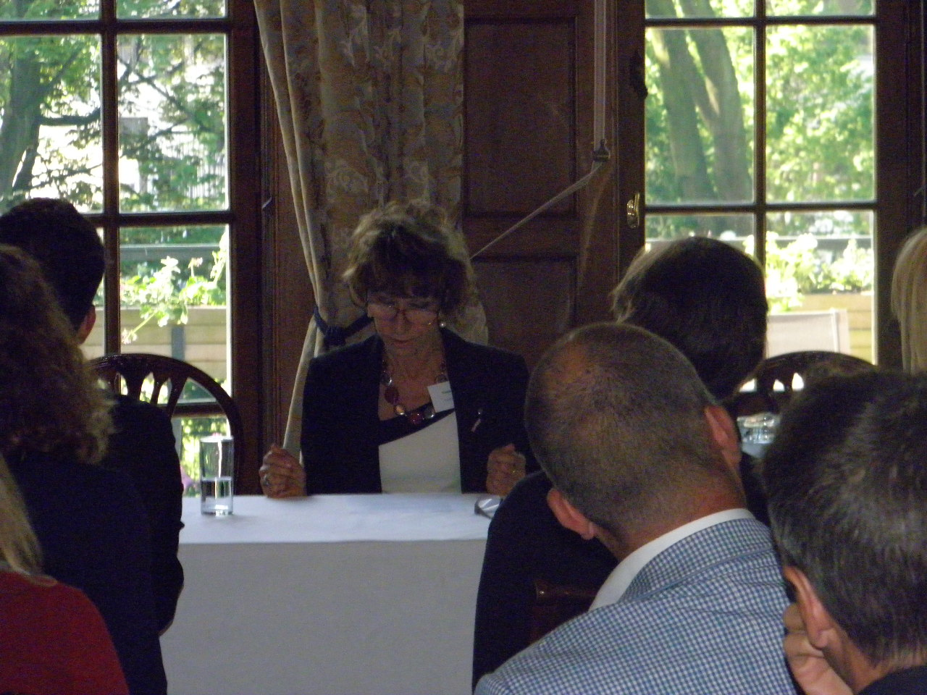
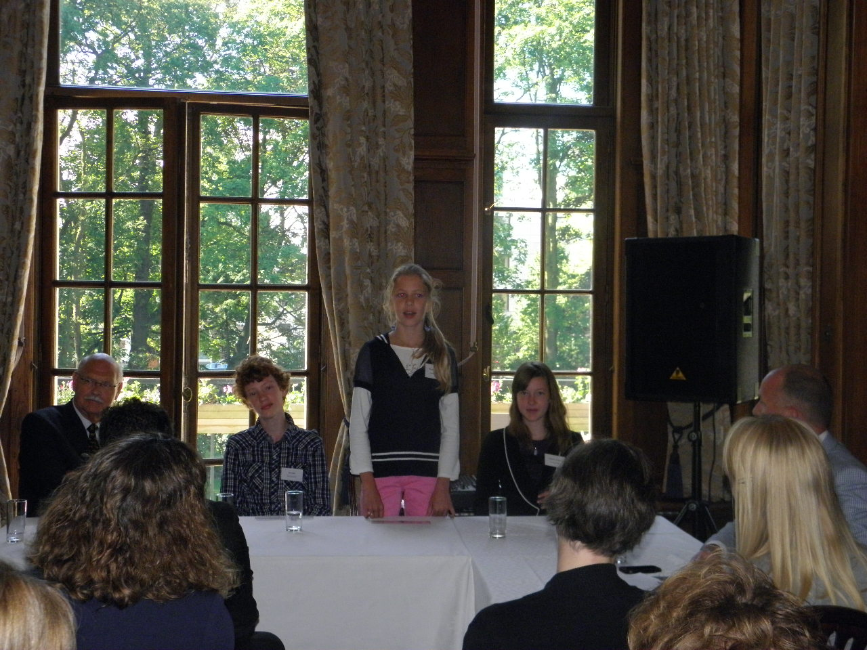
Dutch migration history. For this project, the Huygens Institute of Netherlands History (Huygens ING) and DAAAG (Dutch Australians At A Glance), based at Curtin University, cooperate.
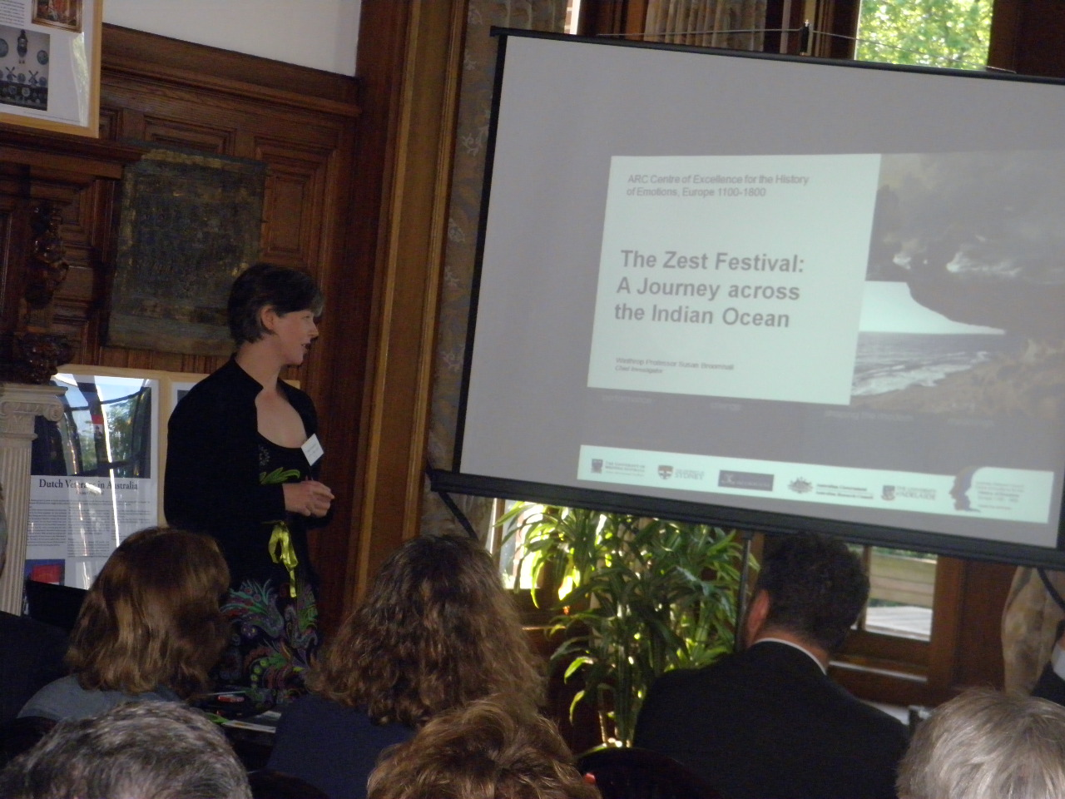
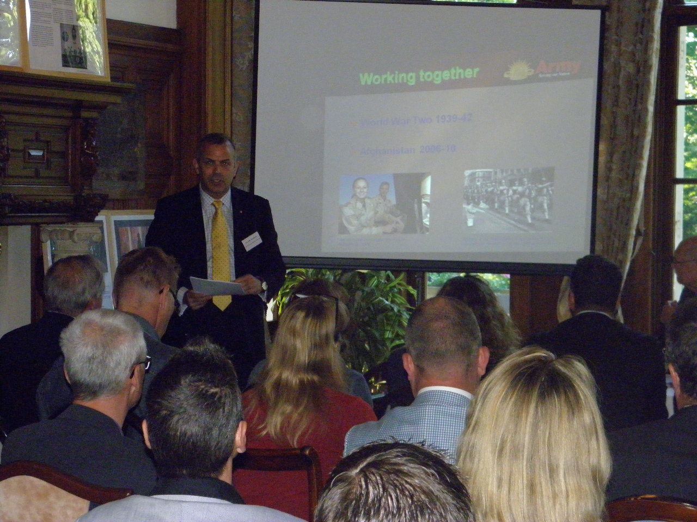
Photos 4-7: Clockwise: Presentations from Col Hutcheson, W/ Prof Broomhall, Dr Peters and Gomarus
College students (source: CIE).
Winthrop Professor Susan Broomhall from the University of Western Australia gave a presentation on the Zest Festival 2012: Starting a Cultural Journey across the Indian Ocean. This festival will be held annually for five years and will be the ‘cultural pulse’ to lead Western Australian Kalbarri and surrounding communities to the commemoration of the 400th anniversary of Dirk Hartog’s landing in 2016. The festival consists of storytelling, music, a bonfire and an exhibition of artefacts and shows that Australian-Dutch relations are also very much alive on a community level.

The third presentation on Australian-Dutch cultural cooperation was from Principal Gerard Janze and three of his students from Gomarus College in Groningen. Gomarus College runs an exchange project with the Calvin School in Kingston, Tasmania. Dutch immigrants from Groningen established the Calvin School in Tasmania in 1962. This educational cooperation involves extensive communication between the students from both countries as well as a visit to meet one another. For the Dutch students who are enrolled in a bilingual education programme, it is a great opportunity to improve their English even further.

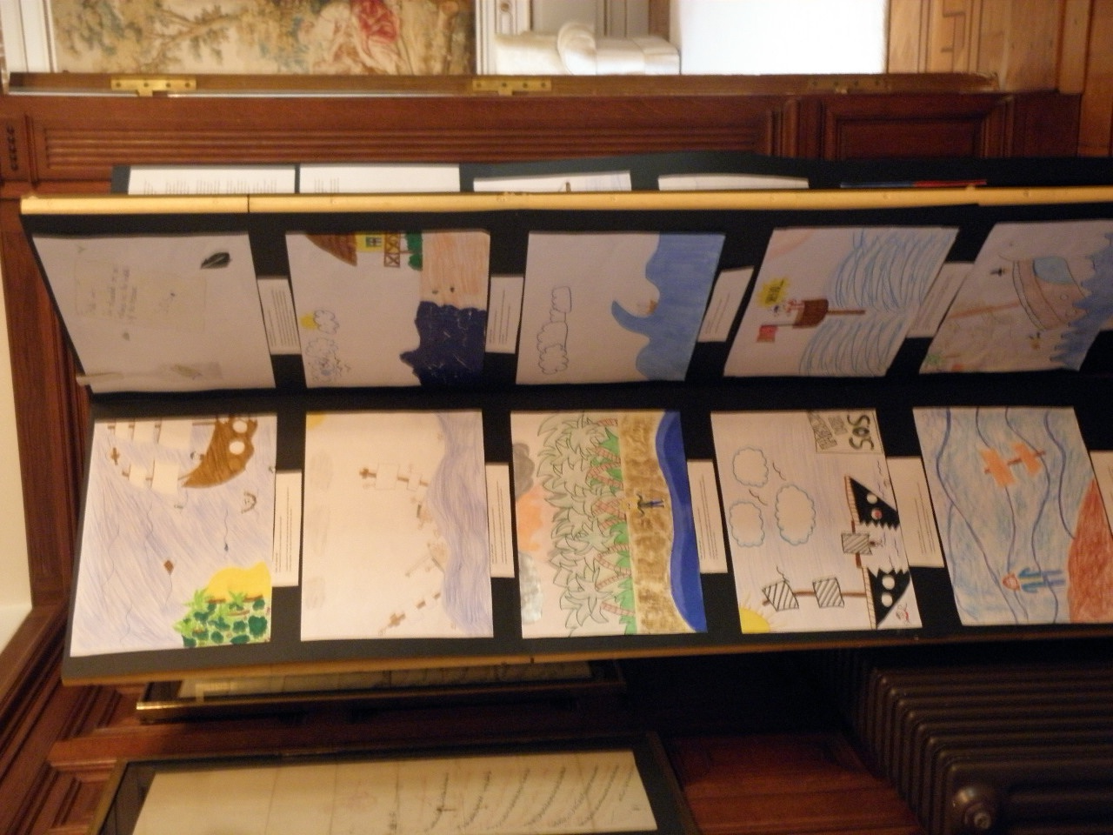
During the coffee and tea break, slides were shown from an intercultural project that involves a school in Kalbarri, Western Australia as well as a school in Leiderdorp, the Netherlands. The children from the schools were asked to make drawings to demonstrate how they would have felt if they had been on board the wrecked VOC ship ‘Zuytdorp’. Children from both schools emphasized that they would miss their family and friends and that they would feel scared if they were stranded on the Western Australian coast.

The film ‘1606 and 1770: A Tale of Two Discoveries’ was also played during the coffee and tea break, in the dining room of the residence. This film underlines the notion that most Australians see the arrival of Captain James Cook in 1770 as the discovery of Australia and not the landing of Dutchman Willem Janszoon in 1606 on Australia’s northern coast. The film explores historic facts and possible explanations for this misconception in a fictitious court, when Janszoon and Cook both defend their claim.
Photo 8: Children's drawings about the wrecking of the Zuytdorp (source: CIE).

- Mutual Cultural Heritage in Practice

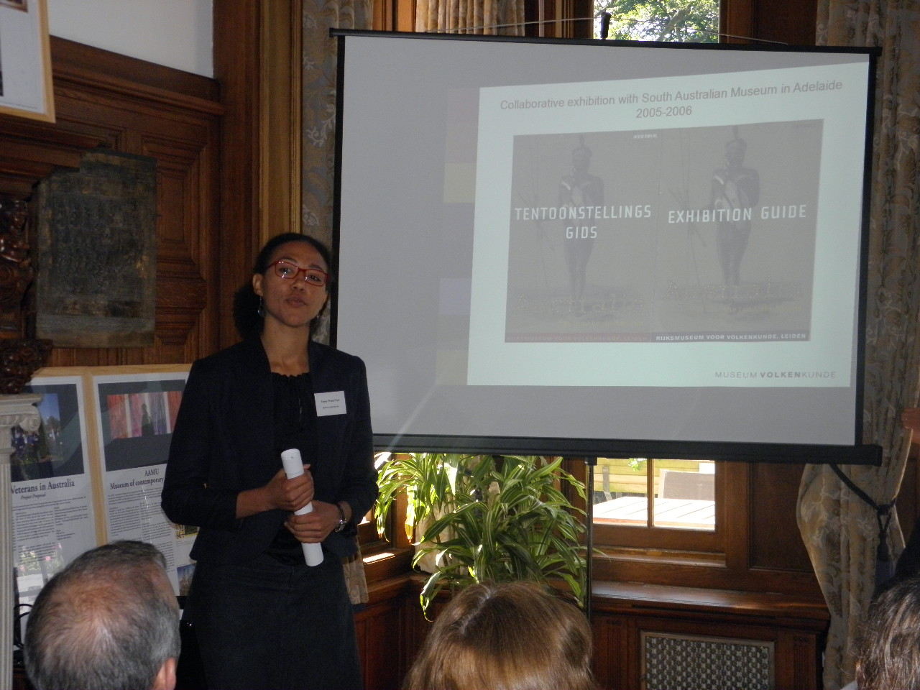
After the break, Stijn Schoonderwoerd, Director of Museum Volkenkunde, started the ‘Mutual Cultural Heritage in Practice’ part of the day. He gave a short introduction about Museum Volkenkunde as a facilitator for sharing knowledge about mutual heritage. He emphasized the Dutch business instinct that always prevailed while doing business overseas and the coming into existence of Museum Volkenkunde.

The introduction of Stijn Schoonderwoerd was followed by a presentation by Dr Fanny Wonu Veys, Oceania Curator at Museum Volkenkunde. During her presentation ‘Sharing knowledge and cultural heritage between Museum Volkenkunde and Aboriginal Australian communities’ Dr Veys explained about a recent Aboriginal photo project that Museum Volkenkunde and other European museums, such as Musee du quai Branly in Paris are currently involved in.
Photo 9: Dr Veys presenting about the Aboriginal photo project (source: CIE).
She also talked about the return of Aboriginal Australian remains to the Bundjalung community in September 2009, during which Museum Volkenkunde acted as a facilitator.

Panel discussions

The first panel discussion ‘Intercultural cooperation from different perspectives – challenges and opportunities’ was chaired by Dr Hans Sondaal, Chairman of the Board of the Aboriginal Art Museum Utrecht (AAMU). The panel consisted of professionals from various backgrounds: Adrian Henham (National Museum of Australia), Dr Fanny Wonu Veys (Museum Volkenkunde), Jean Paul Corten (Ministry of Education, Culture and Science of the Netherlands) and Gerard Janze (Gomarus College). For a detailed outline of this panel discussion, please see page 6.

The ‘Mutual Cultural Heritage in Practice’ part was concluded with the panel discussion ‘Mercantile Heritage – introducing a new theme’. This panel discussion was chaired by Koosje Spitz, project coordinator at CIE. Panel members were representatives of the public and private sectors: Dr Hermina Burnett (Murdoch University), Ian McKenzie (Shell), Dr Nonja Peters (Curtin University), Kees Somer (Ministry of Education, Culture and Science of the Netherlands) and Roelof Hol (National Archives). For a detailed outline of this panel discussion, please see page 8.

Towards 2016

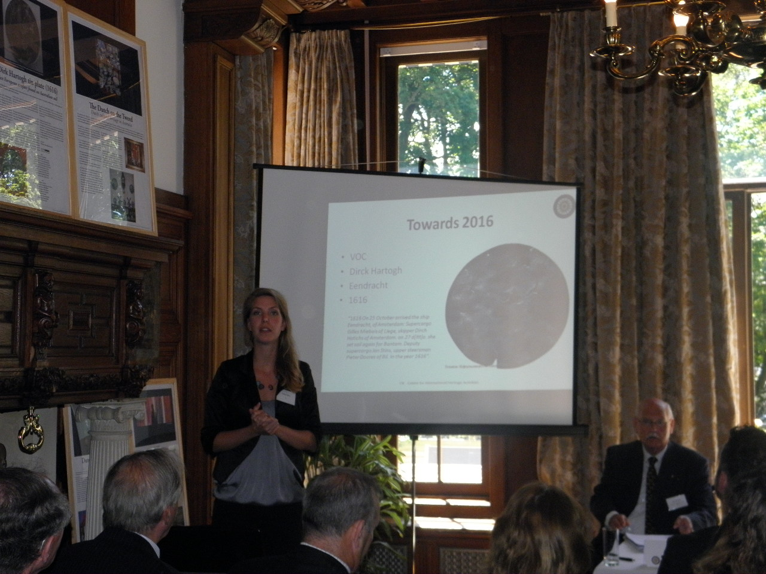
The concluding part ‘Towards 2016’ included a introductory presentation by CIE followed by recommendations and reflections from the audience in regards to Australian-Dutch mutual heritage cooperation. First an overview of the main conclusions and recommendations that were put forward during the Heritage Day in Fremantle, were presented. Hereafter, the audience got the opportunity to reflect their viewpoints on the outcomes of the Fremantle meeting and to share their experiences and visions on 2016 with the other experts present.
Various projects in regards to Australian-Dutch mutual heritage cooperation that could become part of the lead up to the commemorative Dirk Hartog year 2016 were presented. The audience put many suggestions and recommendations forward. It was concluded that in the lead up to Dirk Hartog year 2016, communities need to carry the flag and 2016 needed to be a whole year event, with one flagship event that stood out. Please see page 11 for a detailed outline of the ‘Towards 2016’ presentation.
Photo 10: Koosje Spitz during the 'Towards 2016' presentation (source: CIE).

- Detailed report panel discussion ‘intercultural cooperation from different perspectives – challenges and opportunities’

Intercultural cooperation opens up a scale of opportunities, but is not always free of obstacles. Different cultures come with different standards and values and if these differences are not taken into consideration, difficulties can arise. During this panel discussion various experts working in bicultural Australian-Dutch frameworks discussed their experiences and best practices in regards to intercultural cooperation.

This panel discussion focussed on challenges and opportunities in intercultural cooperation. During the discussions a specific emphasis was put on projects relating to aboriginal culture and arts. As of the Board of the Aboriginal Art Museum Utrecht (AAMU) Dr Hans Sondaal opened the discussion. After this the panel members took the floor.

The following conclusions were drawn:

When working with Australian Aboriginal related art or artefacts, it is important to involve Aboriginal communities at all stages of the project. This has not been always been the case, as until recently Australian and European museums almost never involved Aboriginal communities in their exhibitions and projects on indigenous culture.
The Netherlands put itself at the forefront of museum collections through these Heritage Days, as well as its involvement in collections in the past such as the ANCODS (Agreement between the Netherlands and Australia Concerning Old Dutch Shipwrecks) collection.

A sensitive and often complex matter is the ethical standards for working with Aboriginal artworks and photographs. Different Aboriginal communities have different views on the use of images, recordings or cultural objects. Some Aboriginal communities prescribe that no images of deceased persons can ever be shown again. It is imperative that organisations or individuals consult with the correct community before starting any project involving Indigenous images, recordings or cultural objects.
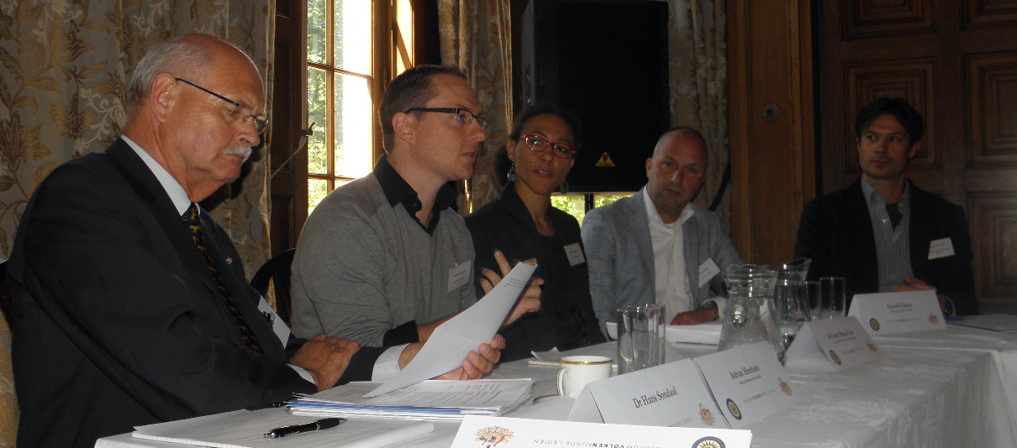
Photo 11: Panel discussion on intercultural cooperation. From left to right: Dr Hans Sondaal, Adrian Henham, Dr Wonu Veys, Gerard Janze and Jean Paul Corten (source: CIE).

Currently there is a lack of a link between Australian and European museums and Aboriginal communities. However, in the Netherlands such a link already exists between AAMU, the Museum of contemporary Aboriginal art in Utrecht, Australian museums and various Aboriginal communities. Also in Canada, such a link exists between Canadian museums and various First Nations tribes. Mr Henham underlined that Canada can serve as an example for Australia, as Canadian First Nations are nowadays heavily involved in projects concerning their people.

At the moment no Aboriginal scholars are included in the Museum Volkenkunde photograph project, but this is desired after the documentation phase has finished. A project has been set up already that will start in Paris in September 2012. It was noted that Aboriginal scholars should be encouraged to come to the Netherlands to follow courses on museum management.

With regard to more general recommendations on intercultural cooperation, educational exchanges at all levels are considered important activities. For example Dutch students learn the importance of intercultural cooperation, while combining it with bilingual programs. Instead of only reading about culture they were encouraged to interview their host family (Dutch immigrants) about cultural differences and their incentives to emigrate. Migration is an important part of the heritage relation and through these sorts of projects; students get a thorough understanding of this.

The Australian Federal structure can form an obstacle for Dutch institutions working with Australia, as the system is considered as rather complex and the involved heritage institutes vary from state to state.

- Detailed report panel discussion ‘mercantile heritage – introducing a new theme’

After a successful panel discussion on mercantile heritage in Fremantle on February 21, the possibilities and validity of this theme were also discussed in The Hague.

Australia and the Netherlands share mercantile heritage through years of mercantile relations. The first contacts between Australia and the Netherlands resulted from incidental contact between the Dutch East India Company (VOC) and Indigenous Australians. In the 20th century, large scale Dutch migration to Australia resulted in the establishment of many Dutch-owned enterprises.

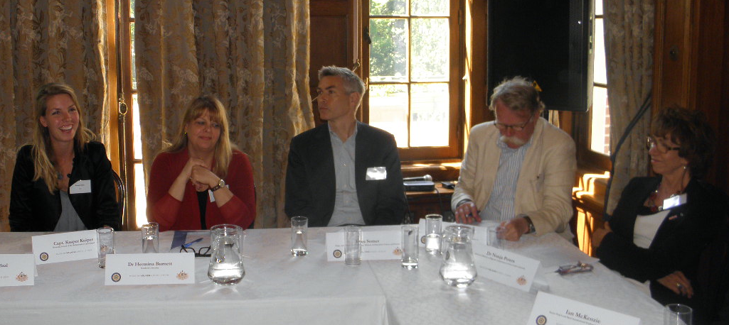
Photo 12: Mercantile heritage panel members. From left to right: Koosje Spitz (chair), Dr Burnett, Kees Somer, Roelof Hol and Dr Peters (source: CIE).
The success of this Dutch entrepreneurship and the presence of many Dutch multinationals in Australia mean that the Netherlands has played an important role in the economic development of Australia. Today, the large number of Dutch companies investing in Australia and the sizeable Dutch expat community intensify the economic ties even more. Since past and present mercantile relations form such an important relationship between the two countries, mercantile heritage could be a new theme that offers new options for emphasizing mutual Australian-Dutch heritage.

Panel members were asked if they thought mercantile heritage to be a valid theme and if so, how the heritage field should approach the private sector. After all, the heritage field can think that a certain project is relevant, but the private sector may not share this opinion. The following conclusions were drawn:

The current relationship between Australia and the Netherlands commenced with the incidental discovery of Australia by the VOC. Trade relations increased in importance in the 19th century, culminating in the first Dutch Consul being appointed in Western Australia in 1863. Trade increased further in the 1930’s, after the Koninklijke Paketvaart Maatschappij (KPM) established a Java-Australia line. In the second half of the 20th century, the Dutch migrants quickly became the most important self-employed group in Australia. The Dutch working mentality was well known and the Dutch were notorious for being able to survive in economically difficult times. It was even said that they would “eat their wallpaper” if they had to.

Australia and the Netherlands share many trade relations. An important part of the success of these relations is due to the notion that Australia and the Netherlands share common values, a common mentality and a similar way of viewing the world. It is much easier to pursue business enterprises in similar cultures. It would be good to see some more clarification on what mercantile heritage is. It clearly results from trading activities and is thus at least partly tangible, but what are the unique elements of mercantile heritage? More research is needed.

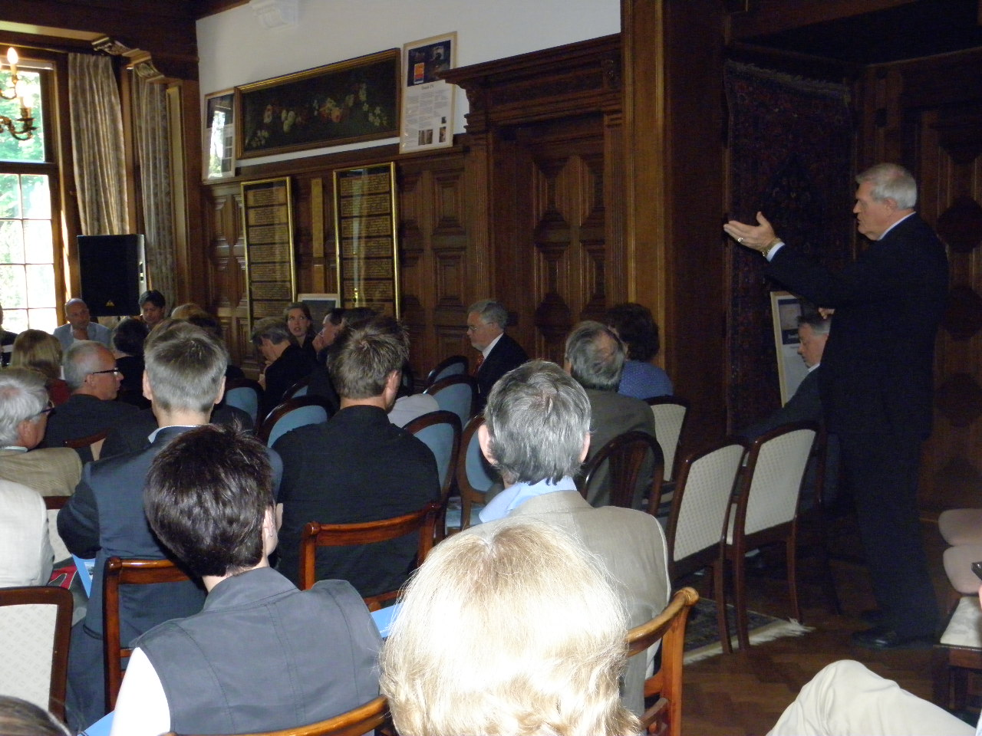
It was noted that a definition of mercantile heritage would be valuable. Mercantile heritage is a valuable theme in the field of mutual heritage, but it needs some more clarification since it is not very well known. Mercantile heritage results from trading activities. In other countries it is therefore mainly tangible (for example, warehouses in Liverpool and Hamburg). But Australian-Dutch mercantile heritage is different. Here, we have two countries that have influenced one another, making the mercantile heritage mostly intangible.

The intangible aspect also refers to the Dutch characteristics that have influenced the mercantile activities. Dutch are very good at entrepreneurship and in assimilating since they speak many languages and easily adapt to different cultures. They are very resilient. Sectors where the Dutch stand out in are engineering and retail. However, from the 1990’s onwards much has changed for Dutch migrants in Australia. There is a different mentality as Dutch and Australians work together now and the Dutch no longer live in separate groups.
Photo 13: Capt. Kuiper raised a question regarding mercantile heritage (source: CIE).
It does not matter when different sorts of heritage get mixed up, since the overall goal is preserving heritage. Mercantile heritage opens up possibilities that are perhaps different than those for traditional heritage. Creating awareness from politicians is also important.

Defining mercantile heritage is however a long-term process. It is not possible to come up with a definition now. However, what are companies interested in if they were to join forces with heritage institutions? More research is needed to answer this question.

Heritage is often not a logical field for large corporate companies, although many have longstanding relations with Australia. For example Shell already established itself in Australia in 1909 and the Australian offices still work according to Dutch structures. All the design work for Shell in Australia is still done in the Netherlands and they get a lot of Dutch input.

A reference was made to the 2006 celebrations, as they also involved collaborations with private partners. An exhibition on Dutch entrepreneurship is a good idea for 2016.

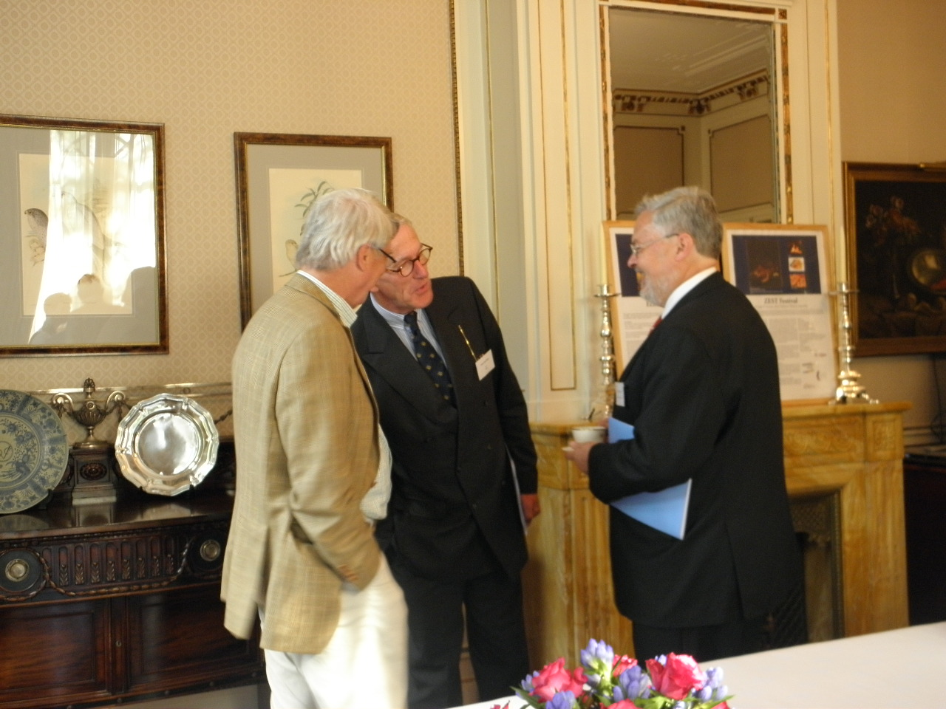
It was noted that the mercantile heritage is not the financing of heritage and that these two notions should not get mixed up. Moreover, businesses only finance projects if this is profitable for them as well.

Nonetheless it could be noted that contemporary business activities may become mercantile heritage in a later phase, as was mentioned during the panel discussion in Fremantle.

It is not easy to get funding for projects. Sponsoring is often very limited, unless sponsors can receive great exposure in return for their funds.
Photo 14: Dr Frits van Dulm (middle) in conversation with H.E. George Troup (right) (source: CIE) CIE).

Interest could be raised if the project concerned a sponsor’s whole sector instead of their own company. Dutch companies for example have greatly influenced the engineering sector in Australia through AUD two billion dollar contracts to dredge the ports of Melbourne as well as Adelaide. The Dutch are also very influential in the banking sector.

However companies will only participate if they see business in projects. Their first priority will always be to run a business. If the heritage field cannot tell the private sector what will be in it for them, then the attempts to cooperate will be futile. In addition many companies with a Dutch heritage are small and of many older companies, the only Dutch that has remained is the name.

An important point that became clear during the mercantile heritage discussion in Fremantle, was that company archives would be a very valuable source for information but that most companies dispose of this information every ten years or so. In the case of Shell Melbourne there used to be an extensive library, but that it is no longer there anymore, which shows there is a shift in corporate priorities.

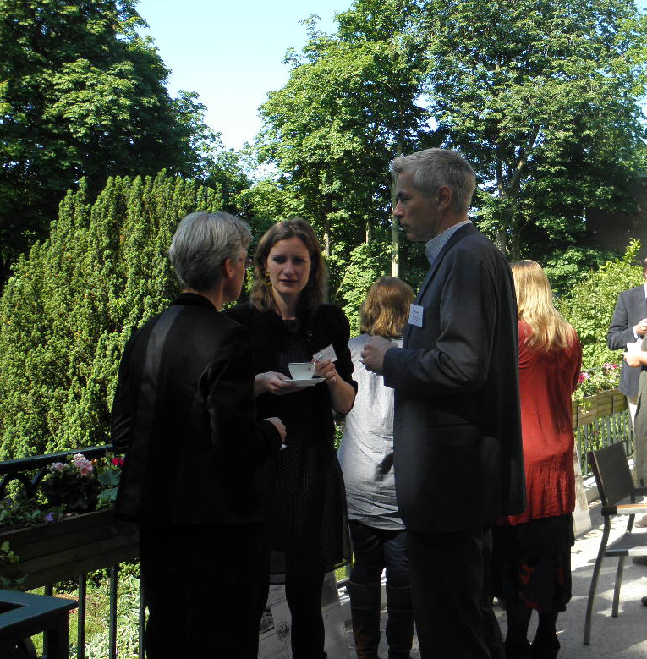
- Detailed report presentation ‘Towards 2016’

During the ‘Towards 2016’ presentation that Koosje Spitz presented, recommendations and ideas for the lead up to Dirk Hartog year 2016 that were put forward during the Australian-Dutch Heritage Day earlier this year in Fremantle.

The main recommendations for creating a concrete and successful coordination for the 2016 activities from the Australian heritage field were the following:

- There is a need for a bilateral commemoration or celebration of Australian-Dutch heritage relations in 2016;
- Define a fund and coordination body in each country for the 2016 activities;
Photo 15: From left to right Marijke van Faassen, Marjolein Cremer and Kees Somer (source: CIE).
- A time line is needed, including important milestones and activities towards 2016;
- Funding is needed, as large- scale projects need to get support from sponsors;
- Business community should be closely involved and connections should be build from early onwards;
- Funding is also needed for academic research in the field of Australian-Dutch heritage, which can be presented in 2016;
- 2016 should be a whole year event, rather than just one celebration. In addition, these activities should vary in that they address different (age) groups, from children to the elderly;
- Ensure that there are facilities for the general public to actually visit the major assets of mutual heritage;
- Activities should be taken up in a broader regional program, supporting community involvement;
- Use an already existing cultural and social infrastructure in the efforts to preserve and continue activities (e.g. Cultural working holiday and exchange programs);
- Joint exhibitions in both countries, to introduce the Australian and Dutch public to mutual heritage;
- After 2016, the cooperation should be continued with new milestones towards other future commemorations and celebrations.

Some of the activities that have already been proposed to CIE in regards to the 2016 Dirk Hartog year:
- Dirk Hartog and the landing of the Eendracht at Cape Inscription
- ZEST festival
- DAAAG
- Australian-Dutch Heritage Travel Guide
- Discovery of a fifth ship at the Zeewyk at Half- Moon reef in the Pelsaert group of the
Abrolhos islands
- Sailing regattas and replica boat journeys
- A film festival based in Perth and also in the Netherlands with cultural ties as its theme
- 20th birthday of Dutch Care
- Digital exhibition and joint exhibitions

VII. Conclusions and recommendations Australian-Dutch Heritage Day The Hague

To conclude the Australian-Dutch Heritage Day, the audience was asked to put forward recommendations and ideas for the mutual heritage cooperation between Australia and the Netherlands, as well as for the lead up to 2016. Many participants voiced their interest in taking part in an Australian-Dutch steering committee.

The main conclusion was:

In the lead up to Dirk Hartog year 2016, communities need to carry the flag and 2016 needs to be a whole year event, with one flagship event that stands out

The following recommendations and conclusions were put forward:

Formalizing the bilateral heritage cooperation may be a useful tool to strengthen heritage cooperation, however the agreement should not be too formal and should primarily be a sign of intent.

Continuity will not come from embassies, since embassies only support and facilitate. It is therefore extremely important to get the community involved. There is a need for the creation of steering committees and public support, with financial support from local companies. The relation between the private and public sector will therefore have to be intensified, according to the recommendations put forward by the mercantile panels during the Heritage Days in Australia and the Netherlands.

It is important to create a guideline of expectations, since everyone will have a different agenda. It will therefore also be wise to create the possibility of registering for participation in the commemorative year, to get an overview of all interested parties. A framework is needed to present plans for 2016. A presentation of concrete plans is also necessary when funding is needed.

It was suggested that music and arts should not be left out in celebrating the bilateral connections. During the 2006 celebrations, various Australian-Dutch music festivals were organized in Australia, with a focus on classical Dutch music from the 17th and 18th centuries. New Dutch Academy Orchestra would be interested to play a role in these activities. It would be valuable to involve the Australian community in the Netherlands in the celebrations. There are many Australians active in the Dutch (classical) music field, which creates possibilities for involving the Australian community in the Netherlands.

Business support will be easier to gain when there is one flagship event that marks a special date, with smaller events before and after covering a full year.

Since different historical events concern different Australian states and cities, places can focus on events that concern them. This way, commemorations can take place throughout the whole year and around the whole of Australia that each focus on different aspects of Australian-Dutch heritage. It was noted that the support from the Federal and State Governments is important, however that sustainable heritage cooperation needs to come from bottom-up rather than top down.

It is advisable to combine the heritage cooperation between the Netherlands and Australia with other large-scale other European-Australian activities, such as the WWI commemoration from 2012-2014.

The 2016 Dirk Hartog activities give room to broaden the Australian-Dutch celebrations to other fields of cultural/political and to include other (smaller) events, including arts, architecture etc.

Follow-up meeting Canberra

Currently, the CIE is working together with the Embassy of the Kingdom of the Netherlands in Canberra to organise a follow-up meeting in Canberra in November 2012. This follow-up meeting will refine the recommendations that were made during the Australian-Dutch Heritage Days in Australia as well as in the Netherlands. With the recommendations and conclusions a roadmap towards 2016 can be outlined and activities agreed to.

Recently, an Australian Corporation of ‘Friends of AAMU’ was established with a Deductible Gift Recipient status. Funds of the Corporation can be used to support Aboriginal artists with programs in the Netherlands and to attend relevant courses here.

